[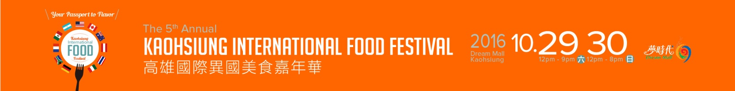](http://www.kaohsiunginternationalfoodfestival.weebly.com)



The 5th Annual Kaohsiung International Food Festival at The Dream Mall presented by Anytime Fitness

"Your Passport to Flavor"

October 29th 12-9pm

October 30th 12-8pm

**FREE ENTRY**

Sponsored by: The Magic Spoon,Cloud 9 Graphics, Dream Mall,

In Association with: Haxstrong

Contact: Ryan Parsons Chairman

 informationkiff@gmail.com

 www.Kaohsiungfoodfestival.weebly.com

 www.facebook.com/KaohsiungInternationalFoodFestival

On the 29th and 30th of October 2016, the largest mall in Asia, Dream Mall will once again play host to The 5th Annual Kaohsiung International Food Festival.

30 of the city's best international vendors will provide food and drink from 20 different countries serving the hungry denizens of Southern Taiwan the most authentic ethnic fare Kaohshiung has to offer.

Entertainment throughout the weekend includes:

* Food eating competition
* Food and Drink Demonstrations
* Kaohsiung's best burger restaurant Competition
* Chopstick Challenge
* Lip Synch Battle
* Live music featuring more than 10 of Kaohsiung’s best international bands and DJs

"This year will mark the 5th year of The Kaohsiung International Food Festival. We wanted to make this year bigger and better than ever so this year the Food Festival will team up with the Dream Mall’s massive Halloween Party.

Attendees can enjoy the very best International Vendors and Musicians from Kaohsiung as well as a weekend of stage events and activities at the 5th Annual Kaohsiung International Food Festival then walk over to the Dream Mall’s Halloween event where there will be costume parties, trick or treating, and much more that will keep the whole family entertained and well fed"

Ryan Parsons Chairman of this year's event.

KIFF is your Passport to Flavor this October at the Dream Mall!